Data Hazards Self-Assessment: Project Name

First Author¹ and Second Author²
¹Address of first author
²Address of second author

PROJECT OVERVIEW
This is a brief introduction to your project. It might include links to places where more information about the project is available. You could also reference some other work here [1].

DATA HAZARDS ASSESSMENT

 | Hazard | Reasoning | Safety Precautions
 | General data hazard
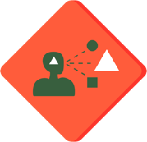 | Reinforces existing biases
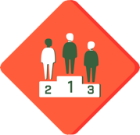 | Ranks or classifies people
 | High environmental cost
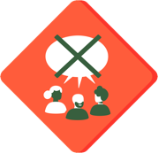 | Lacks community involvement
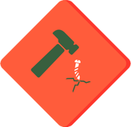 | Danger of misuse
 | Difficult to understand
 | May cause direct harm
 | Privacy
 | Automates decision making
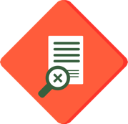 | Lacks informed consent

REFERENCES
- Person, A. & Person, B. An optional reference. Journal title (2022).

